**Assignment Description**

**Language: Oracle SQL**

**Number of Questions: 38**

**Duration: 3 hours**

**Programming Assignment**

**Assignment 1 – Database Creation and Querying Exercises**

**Objectives:**

**In this assignment you will create a database along with tables for which you will Write SQL queries for the instructions specified. These will include addition of constraints, modifications, deletions, insertions and updates. You will also be asked to perform Oracle SQL Joins, sub-queries, functions, triggers, views and indexes as well as packages and procedures. This will be used to assess your overall knowledge of Oracle SQL.**

**STRUCTURE REQUIREMENTS:**

* **Ensure proper syntax and naming convention for example: ensuring the table and column names are all lower case.**
* **Set up the primary keys for each table with constraints listed.**
* **Because you will not be asked to create an actual database in your environment, it is important that your answers clearly illustrate that you understand the questions being asked as well as how to properly structure your answers.**

**REPORTING REQUIREMENTS:**

* **Make sure that you list the section number for each question and title/headings as well as question numbers when submitting your answer.**
* **Please enter all of your answers in a Microsoft Word Doc.**

**SUBMISSION REQUIREMENTS:**

**Submissions will be in the Oracle material GitHub repository.**

**Activities:**

**Section 1-**

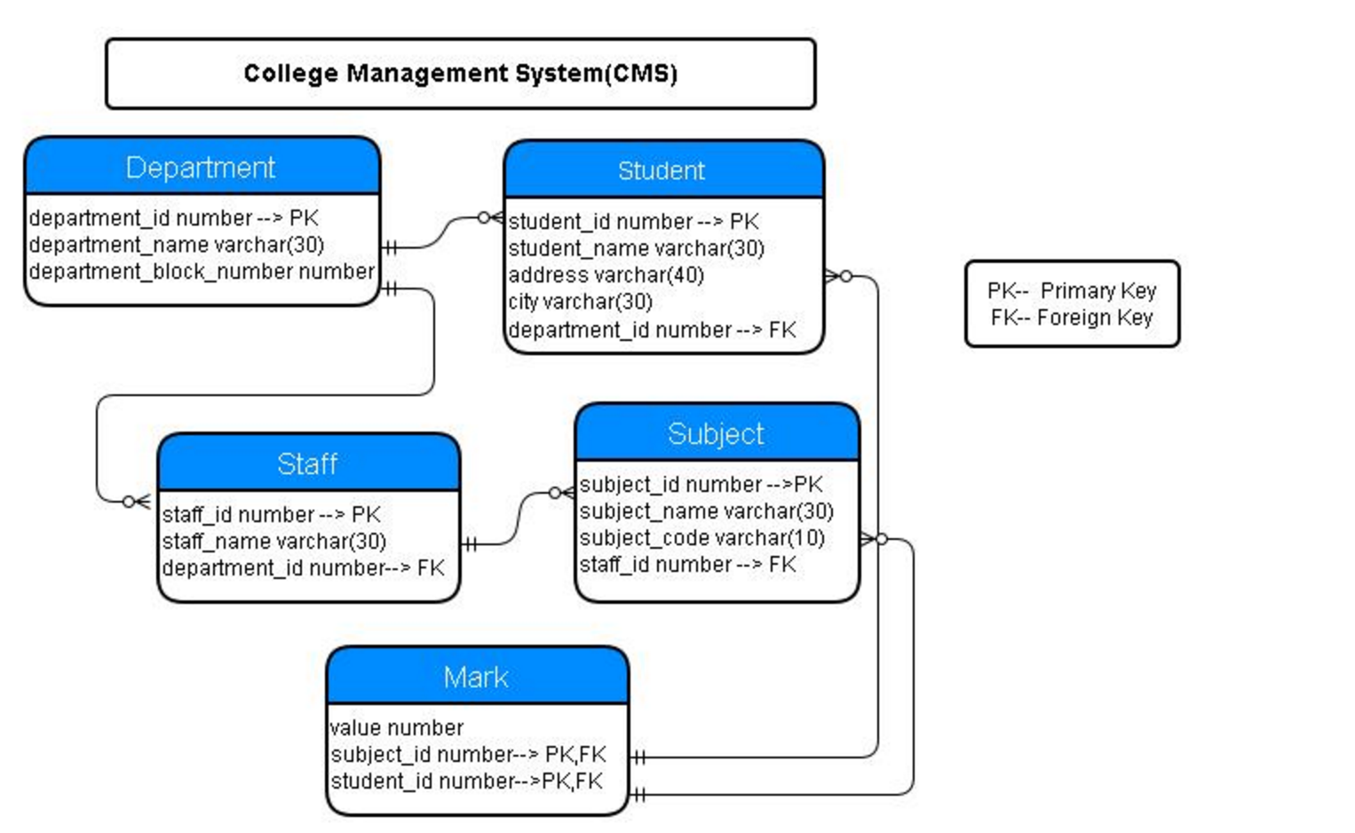

**Creating Tables:**

**Referring to the schema above for reference and using Oracle SQL, create the tables identified below using the following order:**

**TABLES TO CREATE:**

**1-department (department_id number PK, department_name varchar(30), department_block_number number)**

**CREATE TABLE department (**

**department_id NUMBER,**

**department_name VARCHAR(30),**

**department_block_number NUMBER,**

**CONSTRAINT department_id_pk PRIMARY KEY (department_id)**

**);**

**2-student (student_id number, student_name varchar(30), address varchar (40), city varchar(30), department_id number FK)**

**-- added primary key to student_id referenced in ERD**

**CREATE TABLE student(**

**student_id NUMBER,**

**student_name VARCHAR(30),**

**address VARCHAR (40),**

**city VARCHAR(30),**

**department_id NUMBER,**

**CONSTRAINT student_id_pk PRIMARY KEY (student_id),**

**CONSTRAINT department_id_fk FOREIGN KEY(department_id) REFERENCES department(department_id)**

**);**

**3-staff (staff_id number, staff_name varchar(30), department_id number FK)**

**-- added primary key to staff_id referenced in ERD**

**CREATE TABLE staff(**

**staff_id NUMBER,**

**staff_name VARCHAR(30),**

**department_id NUMBER,**

**CONSTRAINT staff_id_pk PRIMARY KEY (staff_id),**

**CONSTRAINT department_id_staff_fk FOREIGN KEY(department_id) REFERENCES department(department_id)**

**);**

**4- subject (subject_id number PK, student_name varchar (30), student_code varchar(10), staff_id number FK)**

**CREATE TABLE subject(**

**subject_id NUMBER,**

**student_name VARCHAR (30), --change this to subject_name to match erd**

**student_code VARCHAR(10),**

**staff_id NUMBER,**

**CONSTRAINT subject_id_pk PRIMARY KEY (subject_id),**

**CONSTRAINT staff_id_fk FOREIGN KEY(staff_id) REFERENCES staff(staff_id)**

**);**

**ALTER TABLE subject RENAME COLUMN student_name to subject_name;**

**-- mistake in instructions, following the ERD**

**5- mark (value number, subject_id number PK FK, student_id number PK FK)**

**CREATE TABLE mark(**

**value_mark NUMBER,**

**subject_id NUMBER,**

**student_id NUMBER,**

**CONSTRAINT value_mark_pk PRIMARY KEY(subject_id, student_id),**

**CONSTRAINT value_mark_sub_fk FOREIGN KEY(subject_id) REFERENCES subject(subject_id),**

**CONSTRAINT value_mark_stud_fk FOREIGN KEY(student_id) REFERENCES student(student_id)**

**);**

**6-Add a constraint by writing a query to add a not null constraint to the column staff_name in the staff table.**

**ALTER TABLE staff MODIFY (staff_name NOT NULL);**

**7-Add a column by writing a query named emailid of type varchar (20) to the student table.**

**-- ADD COLUMN does not work for our version of SQL, returns error**

**ALTER TABLE student ADD emailid VARCHAR2(20);**

**8-Modify the size of the type of field emailid on the student table by writing a query to change it to varchar(50);**

**ALTER TABLE student MODIFY emailid VARCHAR2(50);**

**9-Remove the emailid column on the student table by writing a query.**

**ALTER TABLE student DROP COLUMN emailid;**

**Section 2-**

**Inserting Into Tables**

**10 - Download the following excel sheet in LMS under Documents -> Week 3 -> Oracle hands on:**

* **DEPARTMENT**
* **STAFF**
* **MARK**
* **SUBJECT**
* **STUDENT**

**11 - Insert those excel sheets to their corresponding tables**

**Section 3-**

**Updating Records**

**12 - Update a record by writing a query to update the subject_name in the subject table from Sales to Computer Science and subject_code from 1842 to 1919.**

**UPDATE subject SET subject_code= 1919,subject_name ='Computer Science' WHERE subject_name='Sales';**

**Section 4-**

**Deleting Records**

**13 - Delete the row from the subject table where subject name is Accounting by writing the appropriate query.**

**DELETE FROM subject WHERE subject_name='Accounting';**

**Section 5-**

**Basic Selection of Records**

**14 -** **Display the names of the department in the college by writing the appropriate query. Please note that these must be displayed in ascending order.**

**SELECT department_name FROM department ORDER BY department_name ASC;**

**15- Display the names of the departments where departments block number is between 3 and 10 by writing the appropriate query.**

**SELECT department_name FROM department WHERE DEPARTMENT_BLOCK_NUMBER BETWEEN 3 AND 10;**

**16- Display the names of all the students in the college by writing the appropriate query. Please note these must be displayed in ascending order.**

**SELECT student_name FROM student ORDER BY student_name ASC;**

**Section 6-**

**Selecting Single Rows**

**17- Display the names of the students who are from Chicago, Taylor and San Jose. Please note these must be displayed in ascending order of their respective id.**

**SELECT student_name FROM student WHERE city= 'Chicago' OR city='Taylor' OR city='San Jose' ORDER BY student_id ASC;**

**18-** **Writing the correct query, display the address and city of the students table give the alias as Address_Student.**

**SELECT address || ' ' || city AS Address_student FROM student;**

**19- Display all of the student’s names whose names are of 6 characters in length by writing the correct query.**

**SELECT student_name FROM student WHERE LENGTH(student_name)= 6;**

**Section 7-**

**Selecting Groups**

**20- Display the blocknumber and number of departments in each block by writing the correct query that is ordered by block id. Make sure it is displayed as count (department_name)**

**SELECT department_block_number, COUNT(department_block_number) FROM department GROUP BY department_block_number ORDER BY department_block_number;**

**21-** **Display the number of students in the college by writing the correct query and give an alias as stud_count.**

**SELECT COUNT(student_id) AS stud_count FROM student;**

**Section 8-**

**SQL Joins**

**22-** **Display the names of the department and the student count in each department by writing the correct query. The student count in each department must be in ascending order based on the department name and an alias of student_count for the student count.**

**SELECT department_name, COUNT(student_id) AS student_count FROM department INNER JOIN student ON department.department_id = student.department_id GROUP BY department.department_name ORDER BY student_count;**

**23-** **Display the Student_Name from STUDENT and the Subject_name from SUBJECT where the Subject_code from SUBJECT is greater than 1600.**

**SELECT student_name, subject_name FROM student stud INNER JOIN mark mk ON stud.student_id = mk.student_id INNER JOIN subject sub ON mk.subject_id = sub.subject_id WHERE subject_code > 1600;**

**24-** **Display the Stundent_Name from STUDENTS and the Subject_name from SUBJECT where the value on MARK table is less 3.**

**SELECT student_name, subject_name FROM student stud INNER JOIN mark mk ON stud.student_id = mk.student_id INNER JOIN subject sub ON mk.subject_id = sub.subject_id WHERE value_mark < 3;**

**Section 9 –**

**Selecting Sub-Queries**

**25- Display the block number in which the maximum number of departments is located by writing the correct sub-query**.

**SELECT department_block_number FROM**

**(SELECT department_block_number, COUNT(department_block_number) AS total_department**

**FROM department**

**GROUP BY (department_block_number)**

**ORDER BY total_department DESC**

**) WHERE ROWNUM=1;**

**26- Display the names of the staff who are not handling any subjects by ascending order using the correct sub-query.**

**SELECT staff_name**

**FROM staff**

**WHERE staff.staff_id NOT IN**

**(SELECT subject.staff_id FROM subject)**

**ORDER BY staff_name ASC;**

**Section 10-**

**Functions**

**27-** **Write a function that takes department_id as the input and returns the department_name.**

**Use the function name below:**

**Function name: find_dept_name**

**CREATE OR REPLACE FUNCTION find_dept_name (dept_id NUMBER)**

**RETURN VARCHAR2**

**AS**

**d_name department.department_name%TYPE;**

**BEGIN**

**SELECT department_name INTO d_name**

**FROM department**

**WHERE department_id = dept_id;**

**RETURN d_name;**

**EXCEPTION WHEN NO_DATA_FOUND THEN**

**DBMS_OUTPUT.PUT_LINE('No department name with this id');**

**RAISE;**

**END find_dept_name;**

**-- To Execute: EXECUTE DBMS_OUTPUT.PUT_LINE(find_dept_name( DEPARTMENT_ID ));**

**28-** **Write a function that takes department id as the input and returns the block number.**

**Use the function name below:**

**Function name:  find_dept_block**

**CREATE OR REPLACE FUNCTION find_dept_block (dept_id NUMBER)**

**RETURN NUMBER**

**AS**

**d_block department.department_block_number%TYPE;**

**BEGIN**

**SELECT department_block_number INTO d_block**

**FROM department**

**WHERE department_id = dept_id;**

**RETURN d_block;**

**EXCEPTION WHEN NO_DATA_FOUND THEN**

**DBMS_OUTPUT.PUT_LINE('No department block with this id');**

**RAISE;**

**END find_dept_block;**

**-- To Execute: EXECUTE DBMS_OUTPUT.PUT_LINE(find_dept_block( DEPARTMENT_ID ));**

**29- Write a function that takes the staff id as the input and returns the staff name.**

**Use the function name below:**

**Function name:  find_staff_name**

**CREATE OR REPLACE FUNCTION find_staff_name (staf_id NUMBER)**

**RETURN VARCHAR2**

**AS**

**s_name staff.staff_name%TYPE;**

**BEGIN**

**SELECT staff_name INTO s_name**

**FROM staff**

**WHERE staff_id = staf_id;**

**RETURN s_name;**

**EXCEPTION WHEN NO_DATA_FOUND THEN**

**DBMS_OUTPUT.PUT_LINE('No staff member with this id');**

**RAISE;**

**END find_staff_name;**

**-- To Execute: EXECUTE DBMS_OUTPUT.PUT_LINE(find_staff_name( STAFF_ID ));**

**Section 11-**

**Triggers**

**30- Create a trigger with the name 'trigger_department_af_update' which will display “DEPARTMENTS table has been updated” after an attempt to update the DEPARTMENTS has been made.**

**Trigger name: trigger_department_af_update**

**CREATE OR REPLACE TRIGGER trigger_department_af_update**

**AFTER UPDATE**

**ON department**

**BEGIN**

**IF UPDATING THEN**

**DBMS_OUTPUT.PUT_LINE('DEPARTMENTS table has been updated');**

**END IF;**

**END trigger_department_af_update;**

**31- Create a trigger with the name ‘trigger_department_bf_delete’ which will display “A row has been deleted from DEPARTMENT” before an attempt to delete a row is execute on DEPARTMENT.**

**Trigger name :   trigger_department_bf_delete**

**CREATE OR REPLACE TRIGGER trigger_department_bf_delete**

**BEFORE DELETE**

**ON department**

**BEGIN**

**IF DELETING THEN**

**DBMS_OUTPUT.PUT_LINE('A row has been deleted from DEPARTMENT');**

**END IF;**

**END trigger_department_bf_delete;**

**Section 12-**

**Views and Index**

**32- Create an Index command that will reference all of the students names containing the letter ‘b’ on the Student table.**

**-- Cannot store a query in an index without a function**

**CREATE INDEX stud_names ON student ('student_name');**

**33- Create a view from the staff table that will display staff names.**

**CREATE VIEW staff_names**

**AS**

**SELECT staff_name FROM staff;**

**Section 13-**

**Cursors**

**36- Declare an explicit cursor using the STUDENT table to select of column. Fetch the rows using a loop and display each data retrieved.**

**DECLARE**

**stud_info student%ROWTYPE;**

**CURSOR stud_c IS**

**SELECT * FROM student;**

**BEGIN**

**OPEN stud_c;**

**LOOP**

**FETCH stud_c INTO stud_info;**

**EXIT WHEN stud_c%NOTFOUND;**

**DBMS_OUTPUT.PUT_LINE(**

**stud_info.student_id || ' ' || stud_info.student_name || ' ' || stud_info.address ||**

**' ' || stud_info.city || ' ' || stud_info.department_id || stud_info.emailid);**

**END LOOP;**

**CLOSE stud_c;**

**END;**

**Section 14-**

**PACKAGES AND PROCEDURES**

**37 - Define a package give it the name of College. The definition should include a procedure give it the name of select_departments. It should also include a function that takes a argument of type number and returns a variable of type VARCHAR, give it the name of select_student.**

**CREATE OR REPLACE PACKAGE College AS**

**PROCEDURE select_departments;**

**FUNCTION select_student(stud_id NUMBER)**

**RETURN VARCHAR2;**

**END College;**

**38 - Implement the body of College department. the select_departments procedure should display all column from DEPARTMENT. The select_student function should take the id of the student and return that student name.**

**CREATE OR REPLACE PACKAGE BODY College AS**

**PROCEDURE select_departments**

**AS**

**dept_info department%ROWTYPE;**

**CURSOR dept_c IS**

**SELECT * FROM department;**

**BEGIN**

**OPEN dept_c;**

**LOOP**

**FETCH dept_c INTO dept_info;**

**EXIT WHEN dept_c%NOTFOUND;**

**DBMS_OUTPUT.PUT_LINE(**

**dept_info.department_id || ' ' || dept_info.department_name || ' ' || dept_info.department_block_number);**

**END LOOP;**

**END select_departments;**

**FUNCTION select_student (stud_id NUMBER)**

**RETURN VARCHAR2**

**AS**

**stud_name student.student_name%TYPE;**

**BEGIN**

**SELECT student_name INTO stud_name**

**FROM student**

**WHERE student_id = stud_id;**

**RETURN stud_name;**

**EXCEPTION WHEN NO_DATA_FOUND THEN**

**DBMS_OUTPUT.PUT_LINE('No staff member with this id');**

**RAISE;**

**END select_student;**

**END College;**

**-- To Execute: EXECUTE College.select_departments;**

**-- To Execute: EXECUTE DBMS_OUTPUT.PUT_LINE(College.select_student( student_id ));**